**Project Name**: Building a Linux Web server

**Introduction**: This project involves setting up a LAMP stack, which includes Linux, Apache, MySQL/MariaDB, and PHP, to create a functional web server. Using Debian 10 as the operating system, this project provides hands-on experience in web server administration and web development. The goal is to develop essential skills in managing a web server, deploying websites, and ensuring security, laying a strong foundation for future IT and web development endeavors.

**Motivation**: The motivation for choosing this project is its offering of a practical and in-depth opportunity to learn essential skills in web server administration and web development. The project provides hands-on experience with the LAMP stack (which is consists of Linux, Apache, MySQL and PHP), which is a critical technology in the industry. Additionally, successfully building and managing a Linux web server will provide a solid foundation for future projects and career opportunities in IT and web development. This project enhances technical skills and allows the application of knowledge in a real-world context.

**Area of Work**: Changing Apache Run User and Testing LAMP Server

**Purpose of Work**:

1. Changing Apache Run User: Enhances security and access control.
2. Testing LAMP Server: Validates functionality, compatibility, and security.

**Feasibility Study**: This project is feasible due to its use of widely available open-source software with minimal hardware requirements. Extensive online resources and community support make setup and troubleshooting manageable, ensuring accessibility for gaining web server administration and development skills.

* **Software Required**:

1. Apache HTTP Server (Apache)
2. Linux operating system
3. MySQL or MariaDB
4. PHP

**Changing Apache Run User**:

Changing the user under which Apache HTTP Server runs is typically done for security or permission management purposes. Here’s how we can change the Apache run user on Linux:

The default Apache run user on Debian 10 is **www-data** and the default web root directory is **/var/www/html**. So, as an ordinary user, we won’t be able to create files/directories, or modify existing files/directories in the web root directory. As we are setting up a development LAMP server, this is not what we want. To solve this problem, we should change the Apache run user to your login user and change the owner and group of the webroot **/var/www/html** to our login user.

Step-1:

To change the Apache run user, edit **/etc/apache2/envvars** configuration file with the following command:

* sudo nano /etc/apache2/envvars

Step-2:

Now, we have to modify the **APACHE_RUN_USER** and **APACHE_RUN_GROUP** environment variables.

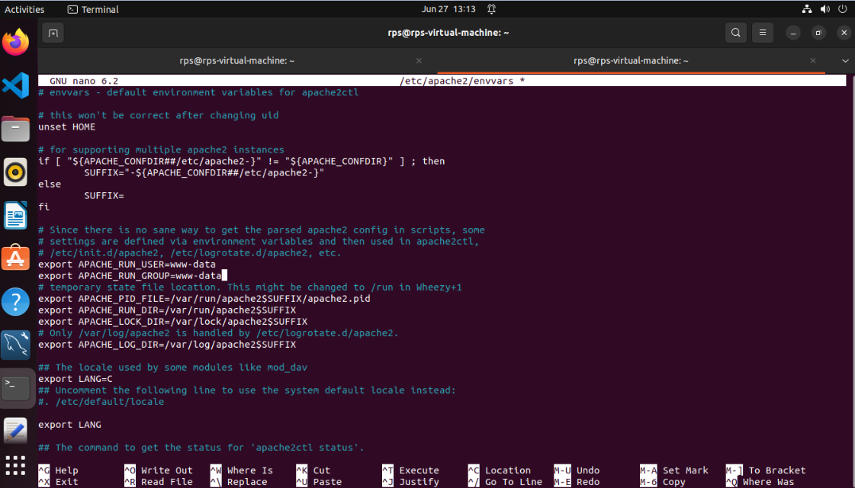

Step-3:

Now, we have to set **APACHE_RUN_USER** and **APACHE_RUN_GROUP** environment variables to our login user’s username (the output of the **whoami** command). Once it’s done, then save the file by pressing **<Ctrl>** + **X** followed by **Y** and **<Enter>**.

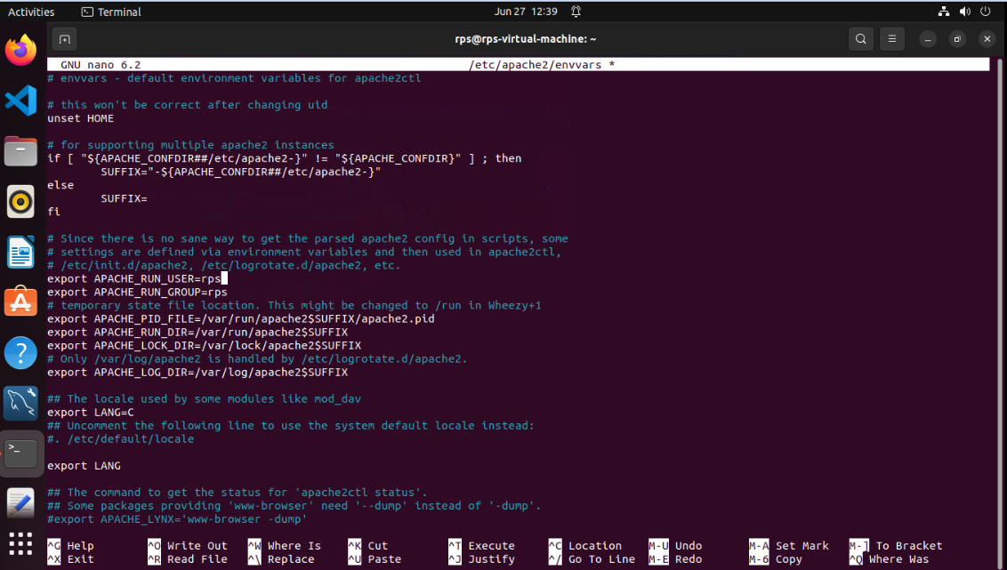

Step-4:

Now, we change the owner and group of the **/var/www/html**directory to the username of our login user with the following command:

* sudo chown -Rf $(whoami):$(whoami) /var/www/html

Step-5:

Now, we have to restart the Apache 2 web server with the following command:

* sudo systemctl restart apache2

**Testing LAMP Server**:

I have created 2 PHP scripts **index.php** and **phpinfo.php** in the webroot **/var/www/html.**

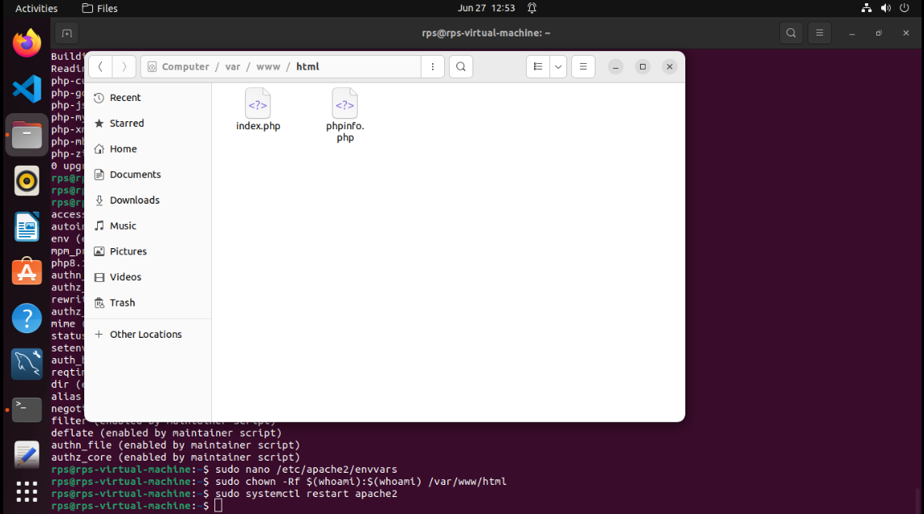

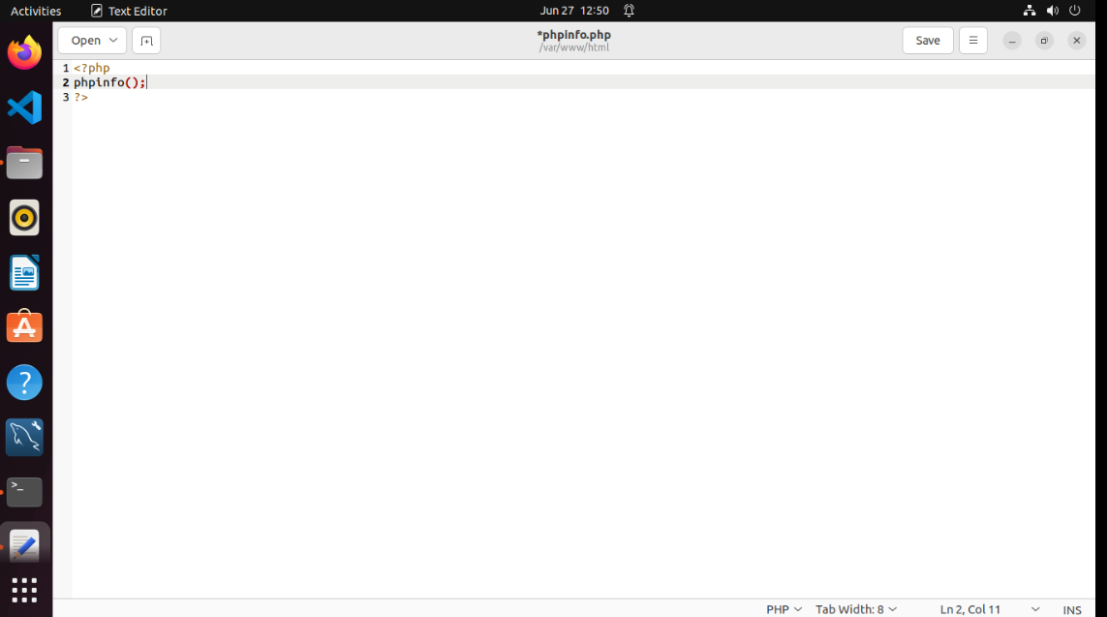

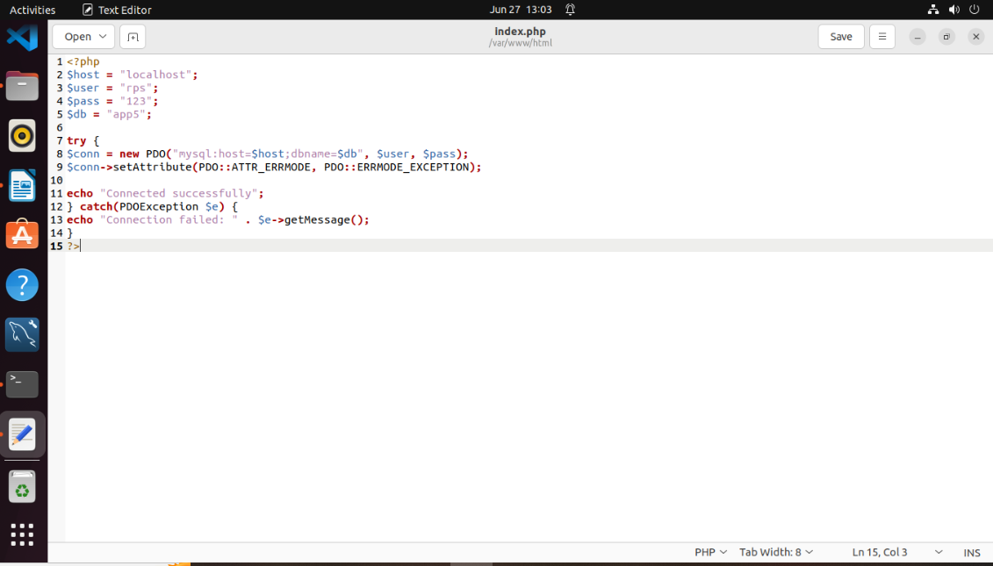

**Outputs**:

Now, we would be able to access the PHP scripts from the browser as you can see in the screenshot below.

* http://localhost

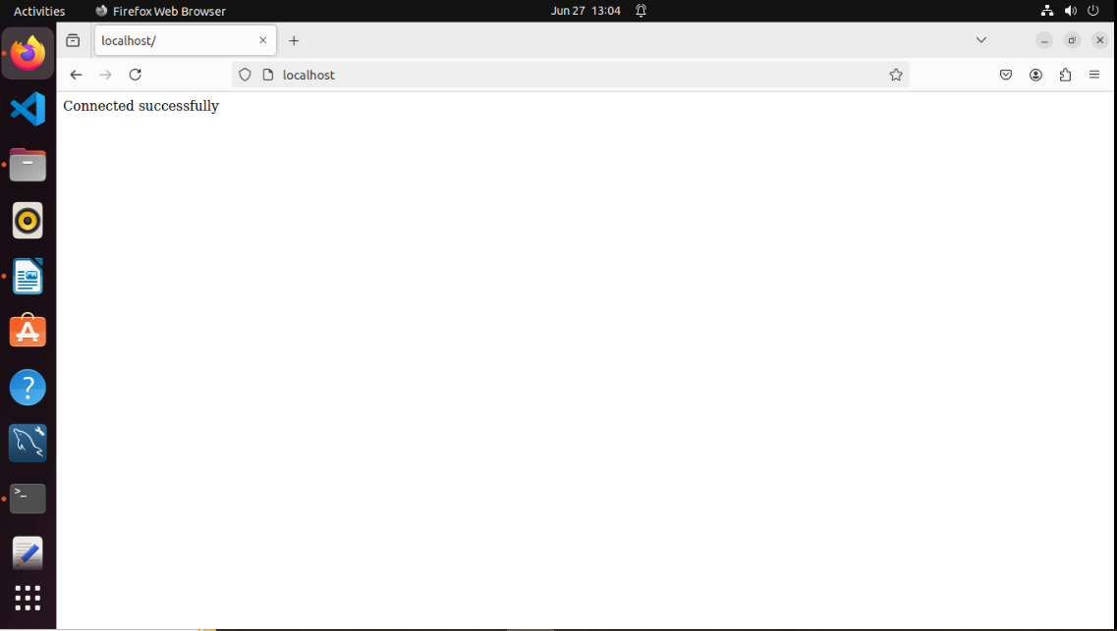

* 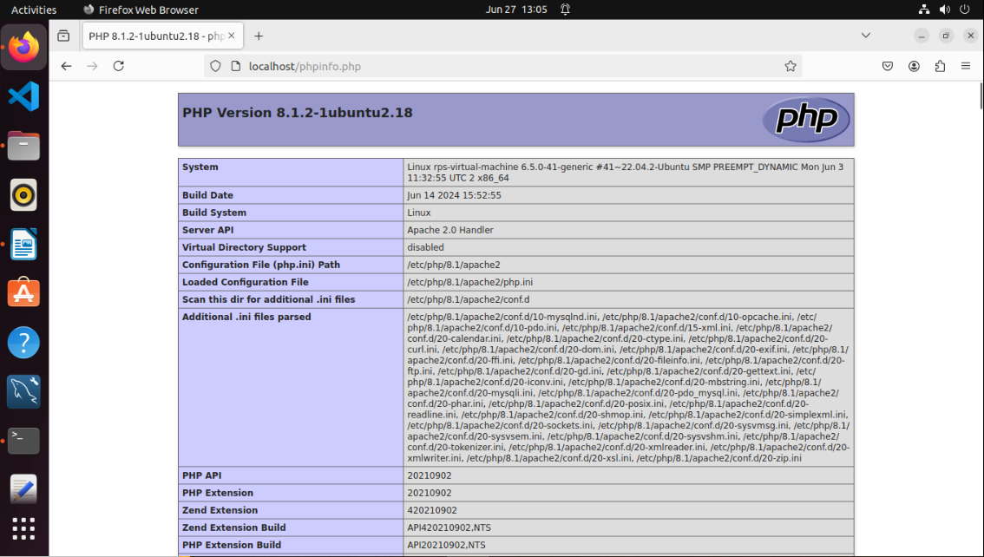<http://localhost/phpinfo.php>

**Conclusion:**

The "Linux Web Server" project is designed to provide comprehensive, hands-on experience in setting up and managing a LAMP stack, using Debian 10 as the operating system. Through this project, we gain essential skills in Linux, Apache, MySQL/MariaDB, and PHP, all of which are critical for web server administration and web development. The practical knowledge acquired through this project serves as a strong foundation for future projects and career opportunities in IT and web development. Additionally, the project emphasizes the importance of security and real-world application, making it a valuable learning experience for anyone interested in web technologies.